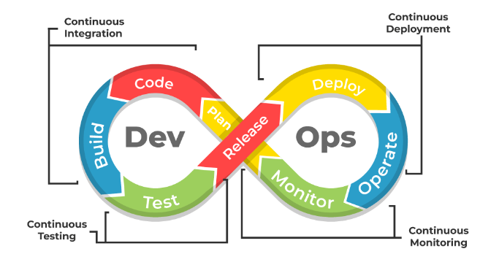

**WiseMind Infotech**

**Falt No-407, 4th Floor Annapurna Block,**  
**Piller No 1052, Near Ameerpet Metro Station**  
**Hyderabad, Telangana,500038.**  
**Contact: +91-7780258655 / +91-7799777051,** **https://wisemindsinfotech.com/**

**DevOps Course Overview**

This DevOps Training is designed to make an individual an expert in all DevOps Concepts from the basics. This course is provided by real-time professionals to help you understand real-world IT scenarios and problems. DevOps Training will help you master various aspects of continuous development and deployment, software development operations, continuous integration, automation of configuration management, and tools like Git, Docker, Jenkins, Kubernetes, Terraform, Prometheus and Grafana.

**Objectives of the Course**

* Understand DevOps Concepts and Tools
* Deploy main DevOps tools
* Implement automated system updates and the DevOps lifecycle
* Understand virtualization and performance
* Provide perfect security for the entire infrastructure

**Course Syllabus**

**Linux and Shell Scripting**

1. Introduction to Linux
2. Basic Commands and Utilities
3. Shell Scripting Basics
4. Advanced Shell Scripting
5. File Management and Permissions
6. Process Management
7. Networking Commands

**Git and GitHub**

1. Introduction to Version Control
2. Git Basics and Installation
3. Repository Management
4. Branching and Merging
5. Collaborative Workflows
6. GitHub Features and Integration
7. Advanced Git Commands

**Docker**

1. Introduction to Containerization
2. Docker Installation and Setup
3. Docker Commands and Concepts
4. Building and Managing Docker Images
5. Docker Compose
6. Networking in Docker
7. Docker Swarm and Orchestration

**Kubernetes (K8s)**

1. Introduction to Kubernetes
2. Kubernetes Architecture
3. Deploying Applications
4. Managing Pods and Nodes
5. Services and Networking
6. Persistent Storage in Kubernetes
7. Helm Charts and Package Management

**Jenkins**

1. Introduction to CI/CD
2. Installing and Configuring Jenkins
3. Jenkins Pipelines
4. Integrating Jenkins with SCM
5. Automated Testing with Jenkins
6. Jenkins Plugins
7. Monitoring and Maintenance

**Terraform and Ansible**

1. Introduction to Infrastructure as Code (IaC)
2. Terraform Basics and Configuration
3. Resource Management with Terraform
4. Advanced Terraform Concepts
5. Introduction to Ansible
6. Ansible Playbooks and Modules
7. Automating with Ansible

**Prometheus and Grafana**

1. Introduction to Monitoring and Metrics
2. Installing and Configuring Prometheus
3. Collecting and Querying Metrics
4. Introduction to Grafana
5. Visualizing Metrics with Grafana
6. Alerts and Notifications
7. Integrating Prometheus and Grafana

**Cloud Computing**

1. Introduction to Cloud Computing
2. Cloud Service Models: IaaS, PaaS, SaaS
3. Cloud Deployment Models: Public, Private, Hybrid
4. Benefits and Challenges of Cloud Computing

**Introduction to Google Cloud Platform (GCP)**

1. Overview of GCP
2. Core Services and Features
3. Setting up GCP Account
4. Navigating GCP Console

**GCP Administration**

1. Compute Engine
   * VM Instances
   * Managing Instances
   * Snapshots and Images
2. Identity and Access Management (IAM)
   * Roles and Permissions
   * Service Accounts
   * Policies and Security
3. Cloud Storage
   * Buckets and Objects
   * Storage Classes
   * Access Control and Security
4. Virtual Private Cloud (VPC) and Load Balancers
   * VPC Networks and Subnets
   * Firewalls and Routes
   * Load Balancer Types and Configurations
5. App Engine and Cloud Run
   * Deploying Applications
   * Managing Services
6. Cloud Functions
   * Event-Driven Computing
   * Deploying and Managing Functions
7. Cloud SQL
   * SQL Instances
   * Database Management
   * Backup and Restore

**GCP DevOps**

1. Google Cloud Source Repositories (GCSR)
2. Google Container Registry (GCR)
3. Google Kubernetes Engine (GKE)
4. Cloud Deployment Manager
5. Cloud Operations Suite
   * Monitoring
   * Logging
   * Tracing
6. Cloud Build

**DevOps Training Duration**

* **50 Hours**

**Additional**

1. **Sample Resume Preparation**
   * Structuring your resume
   * Highlighting key skills and experiences
   * Tailoring your resume for DevOps roles
2. **Interview Questions**
   * Common DevOps interview questions
   * Scenario-based questions
   * Technical questions on GCP and Azure
   * Behavioural questions